Lab 12 - PostgreSQL

Neven Said
Lab 12 (Friday, May 2nd)
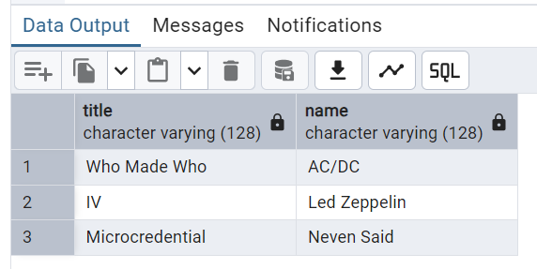

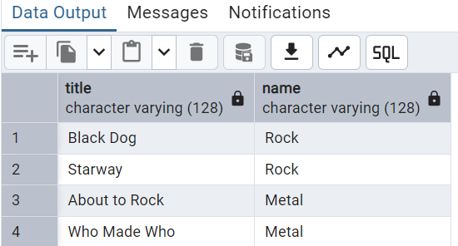

Lab exercise 12C
1. Read all students and their majors
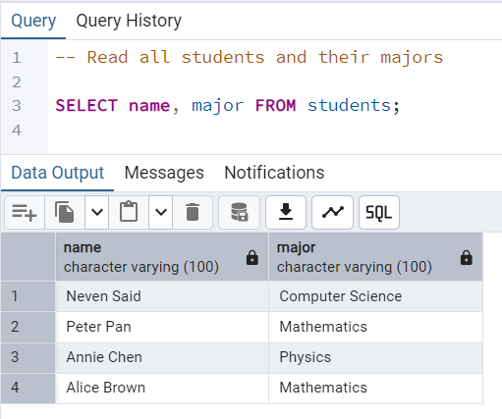

4. Update Data

2. Read the titles of the courses each student is enrolled in.
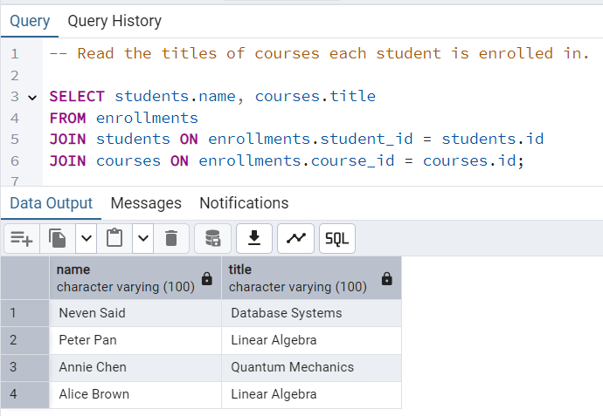

3. Read all students with grades and courses.
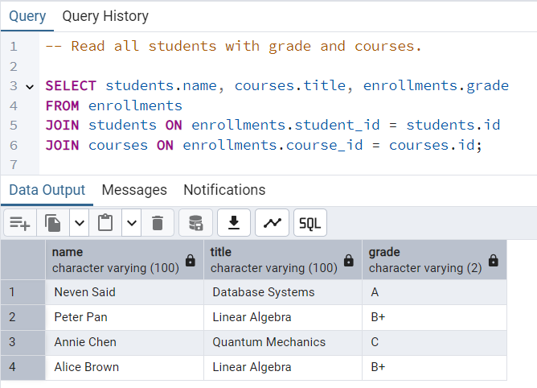

4. Read how many students have a grade of B+.
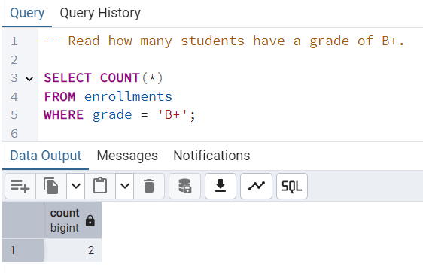

5. Read the names of students who have a grade of B+.
